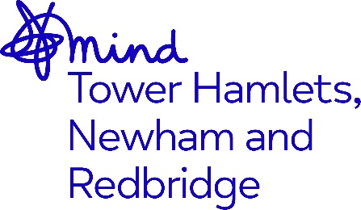

JOB ADVERT

Recovery Worker

Newham Together Café

Job Title: Recovery Worker – Newham Together Café

Grade: £26,268.00 per annum, pro rata for Part time hours

Hours: The hours cover 2pm to 9pm or 9.30pm seven days a week.

Accountable to: CEO/Operations Director

Supervised by: Service Manager/Team Leader

Location: Stratford, Newham

Contract Term: Permanent

Closing Date: 5pm Monday 29th April 2024
Interviews: Thursday 2nd May 2024

Job description

Permanent role in Stratford, London

Mind in Tower Hamlets, Newham and Redbridge are seeking Recovery workers to join the team at the Together Cafe: our out-of-hours drop-in service providing a safe and welcoming space for people who are feeling distressed, seeking support and advice for their mental health, there and then. The service is based in Stratford, London. Staff within the service will provide person-centred, practical, and emotional support, face to face or via telephone on a one-to-one or group basis to individuals experiencing mental health distress. This will consist of 1:1 and group support; de-escalating and providing interventions, signposting for specialised or longer-term support, and delivering collaborative self-management plans with clients to improve mental wellbeing.

About Mind in Tower Hamlets and Newham
We are a local, registered charity affiliated to National Mind. The organisation supports those with mental health issues in Tower Hamlets, Newham and Redbridge towards recovery and leading a better life.

We believe that everyone has the right to access comprehensive services which enables them to reach their full potential and to work towards their recovery. We value diversity as a strength and our staff teams are from a variety of backgrounds which helps us to deliver services which are culturally aware and responsive to the needs of the diverse communities we serve.

Who we need
The right person will join our team in providing support in a safe, calm, and empathic environment and ability to support individuals who are at a point of mental health crisis and accessing the service.
Why work with us
You will develop your understanding and experience of mental health issues and contribute to the development of our services. The hours allow you to balance your life with your work and you will have a job that makes a difference for people.
See job description for more details and a description of our benefits.
How to apply
Please send your CV and supporting statement outlining how you meet the criteria in the person specification to recruitment@mindthnr.org.uk

