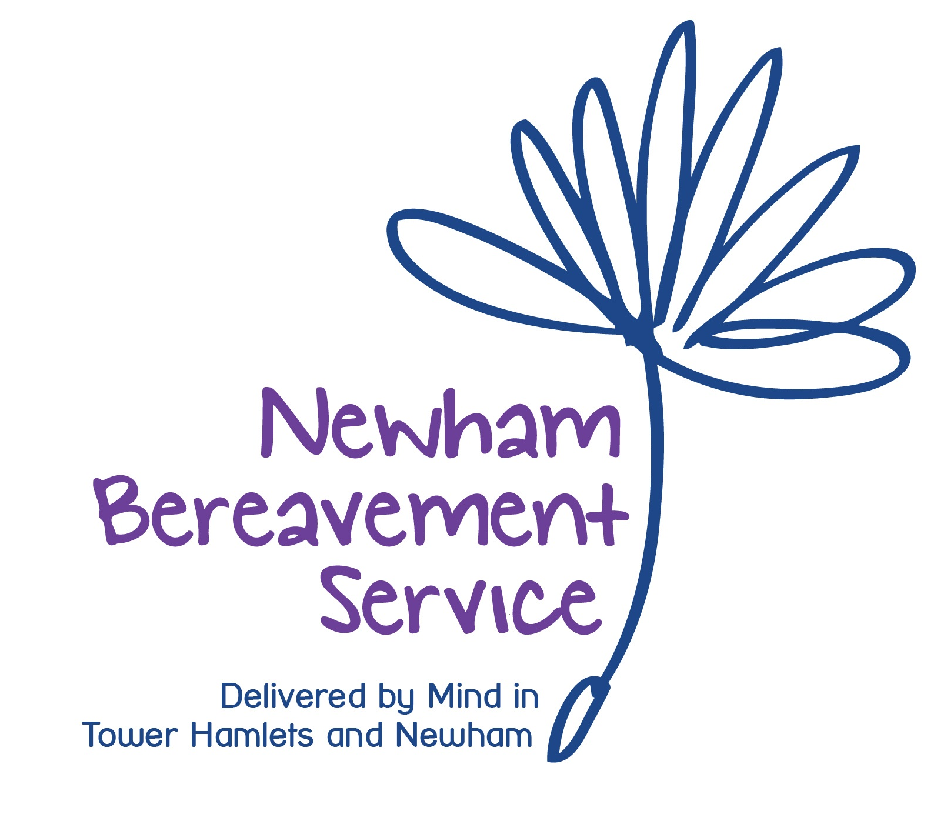
Newham Bereavement Service
PERSON SPECIFICATION
FOR CLINICAL PLACEMENT COUNSELLORS

Qualifications

To be qualified in any of the following:
- Counselling/Psychotherapy/Counselling Psychology.
- Or to be currently training on any of the following courses:
Dip/BSc/MSc/MA/Doctorate
Counselling/Psychotherapy or Counselling Psychology
If you are already qualified, please bring your certificates to the interview with you, should you be shortlisted)

- If in training, to be in at least the second or third (or above) year of their training. Please give details of the course.

- Please give details of any additional counselling workshops or courses that you have attended.

Personal Therapy

- To have had a minimum of 20 sessions of personal therapy and to be in therapy for the duration (if in training) of the contract with Mind until qualified.

- Please give details of your experience of personal therapy, length of time and the therapist’s name and accreditation body (BACP/UKCP)

Counselling Experience and Skills
(to be demonstrated in the application form or at interview)

- Please write about your motivation to be a counsellor and/or psychotherapist and what skills and attributes you will bring to the role.
- Please talk about your awareness (or experience) of working with clients in
a Time Limited Way.
- Please tell us of your personal experience of loss.

- Please tell us of any experience you may have of mental health issues. (This can either be your own personal experience or experience of others).

- Please tell us of your ability to communicate effectively both verbally and in writing.

- Please tell us of your ability to undertake all administrative duties in a timely and professional manner.

- Please tell us why you have chosen to apply for this post at Mind in Tower Hamlets, Newham and Redbridge.

- Would you be able to commit to at least a one year contract as a clinical placement counsellor with Mind in Tower Hamlets, Newham and Redbridge.

(to be demonstrated at interview)

- awareness of trans-cultural issues in counselling – This can be from working with other colleagues at college, general life experience or knowledge and skills learnt from courses or books.

- awareness of LGBTQIA (Gay, Lesbian, Bisexual, and Trans-gendered) issues in counselling- this can be from working with other colleagues at college, general life experience, specific courses taken or from books read.

- awareness of safeguarding concerns

Placement description

To provide counselling sessions to 3 clients referred to the Newham Bereavement Service at Mind in Tower Hamlets and Newham. You will work in a largely autonomous manner, receiving support from the Counselling Manager and Counselling Assessors or the Counselling Administrator, plus group supervision twice a month from one of the Mind clinical supervisors totalling 1. 5 hours per month counted as per the BACP minimum requirement.

(If additional hours are needed, such as for UKCP requirements, external supervision should be organised and paid for by the counsellor)

Duties and Responsibilities:

To provide the service with three individual counselling sessions per week for a minimum period of one year (apart from Bank Holidays and when the Counselling Services are closed over holiday periods)

Holiday/annual leave breaks for counsellors: a maximum of five weeks per annum, with no more than 2 weeks in a row
- To provide each client short-term, time limited counselling, either for 6 to 12 sessions and to conduct reviews with the clients half way through therapy in order to assess the counselling progress.

- To attend two group supervision sessions per month (1.5 hours)
(meeting BACP requirements)

- To identify and communicate to the Counselling Manager and Mind clinical supervisor any concerns about the client or the counselling relationship.

- To collect data on each client to meet existing monitoring standards.

- To attend Mind trainings offered, on topics that are relevant to the post

- To complete contracts and core forms on the first session with each client and to complete the final core and Mind Survey forms at the end of the client’s final counselling session.

- To maintain up-to-date clinical records (such as updating assessments, referral forms, measuring outcomes and client notes) which are the property of Mind and must be kept on the premises and returned to the Counselling Manager once the counselling has finished.

Communication and working relationships.

- All clinical placement counsellors are managerially and clinically accountable to the Counselling Manager.

- To maintain awareness of other services within Mind and wider community for additional or alternative referral.

General:

- To adhere to all of Mind in Tower Hamlets, Newham and Redbridge policies, procedures, and core values.

- To adhere to the BACP Ethical Framework.

- To keep abreast of current psychological developments as they relate to the post.

……………………………………………………………………………………………………

Please sign below:

Placement Counsellor’s signature: Date:

……………………………………………. …………………….………..

Counselling Manager’s signature Date:

…………………………………………….. ………………………………..

Mind in Tower Hamlets, Newham and Redbridge Counselling Services are BACP accredited service and adhere to the BACP Ethical Framework for Good Practice in Counselling and Psychotherapy.



