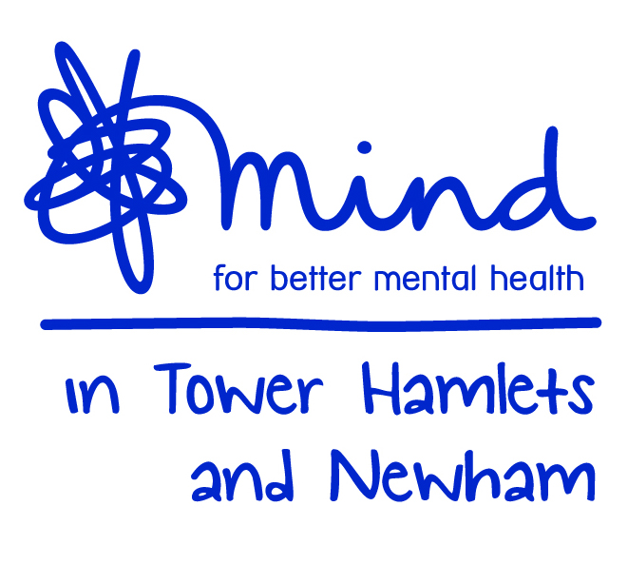

Clinical Placement Application Form

Mind in Tower Hamlets and Newham Counselling Service

Name:

Address:

Postcode: | Home/Telephone No:  Mobile:
E-Mail

Name and Level of Current or last Counselling/Psychotherapy Course:

What year are you currently studying in? /or the year when you finished your last course?

Address of current or last college/university

Contact Person & Telephone No of Person at college/university:

Date Begun: |  | Date Expected To Finish/or Finished:
Number of clinical hours experience:

Please place an ‘X’ against the placement you are interested in applying for:
(please note you can only select one location)

Tower Hamlets and Newham Talking Therapies
Brief counselling and bereavement counselling for Step 2 or Step 3 clients

Newham Bereavement Service
Bereavement counselling

Please tick your availability for Client Work:

Mon |  | Tues |  | Wed |  | Thurs |  | Fri
 | Y/N |  | Y/N |  | Y/N |  | Y/N |  | Y/N
10 – 2pm |  | 10 – 2pm |  | 10 – 2pm |  | 10 – 2pm |  | 10 – 2pm
1 – 5pm |  | 1 – 5pm |  | 1 – 5pm |  | 1– 5pm |  | 1 – 5pm
4 – 8pm |  | 4 – 8pm |  | 4 – 8pm |  | 4– 8pm |  | 4 – 8pm
 |  |  |  |  |  | 5 – 9pm

Please note:
Those who are still in training will be expected to complete two years on contract.

For those who are qualified, a one-year contract will be offered, but can extend to two years upon request.

Clinical Supervision Groups

Please underline and tick your availability for supervision groups:

Mon |  | Tues |  | Wed |  | Thurs |  | Fri
 | Y/N |  | Y/N |  | Y/N |  | Y/N |  | Y/N
09:30-11:30
11-13:00 |  |  |  |  |  |  |  | 10-12
2 – 4 |  | 2 – 4 |  | 2 – 4 |  | 2 – 4 |  | 2 – 4
4 - 6 |  | 4 - 6 |  | 4 - 6 |  | 4 - 6 |  | 4 - 6
6 - 8 |  | 6 - 8 |  | 6 - 8 |  | 6 - 8 |  | 6 - 8
If your availability falls outside the hours shown please state below the hours you are available:

All supervision groups are held fortnightly and attendance is compulsory.

CASE MANAGEMENT:

Mon |  | Tues |  |  | Wed |  | Thurs |  | Fri
 | Y/N |  | Y/N |  |  | Y/N |  | Y/N |  | Y/N
10 – 2pm  (NBS Only) |  | 10 – 1pm  (NBS Only) |  | 1 – 3pm |  |  | 10 – 2pm  (NBS Only) |  | 1 – 3pm (THTT/NTT Only)
2 – 3pm |  | 1 – 5pm |  | 3pm – 5pm (NBS Only) |  |  | 2– 5pm
4 – 8pm  (NBS Only) |  |  |  | 5pm – 8pm  (NBS Only)

One to one case management is held once every 4 weeks and attendance is compulsory.
References: - 2 Required

References should be from the following persons:

1) Current or recent course tutor (or clinical supervisor if qualified)

2) Current or most recent employer or placement manager

1)  Name, position and Postal Address  (please include email address) |  | 2)  Name, position and Postal Address  (please include email address)

Paid/Voluntary employment

Organisation | Title of job or role | Paid or voluntary | Dates

Please read and outline below, all the criteria listed in the person specification form.

Please note: You may write out the question if you wish, before answering it and attempt to give clear examples, both professional and personal to illustrate your points. (no more than 1000 words)

You may use 2 A4 Pages (Please use Ariel Font 12)

Please give details of any counselling placements you have had and how many counselling hours you have accumulated that have been clinically supervised. (Please note we do not accept applications with less than 50 hours of clinical experience).

Please give a brief description of your philosophy and theoretical orientation when working with clients.

Please tell us how many hours of personal therapy you have had and the modality of your therapist(s) (Essential: To have had a minimum of 20 sessions of personal therapy and to be in therapy for the duration (if in training) of the contract with Mind until qualified.)

Please provide name and address of your current therapist:

Therapist accreditation status and number:

Can you offer counselling in any other languages? - please list?

How would you rate your IT skills? Have you ever used any form of data base systems before? Please specify if you have experience using IAPTus or any other similar database.

Please note that you will only be offered a placement at Mind in Tower Hamlets an Newham after:
- Successful completion of an interview
- On receipt of 2 satisfactory references
- On receipt of Disclosure and Barring Service Clearance
- Your agreement to commit to a minimum of a year’s placement
- Signing of a 3-way contract between the Clinical Delivery Manager, the College Tutor (if in training) and the Volunteer Counsellor
- After attending induction training

Please sign and date below:

Name: ______________________________________________________

Signature: ___________________________________________________

Date: _______________________________

Many thanks for completing the application form. Please return the application as soon as possible to counselling@mithn.org.uk quoting MIHTNCPV

Only those applicants who are shortlisted for interview will be notified by email.

Thank you

Mind in Tower Hamlets and Newham Counselling Service is a BACP accredited service and adheres to the BACP Ethical Framework for Good Practice in Counselling and Psychotherapy

