
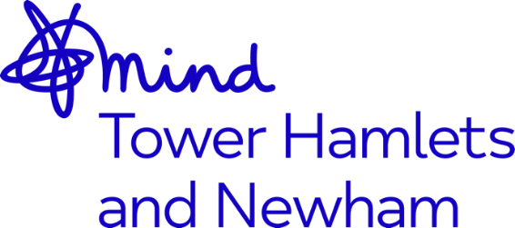

Job Advert: Peer Support Worker - Redbridge Mental Health Peer Project
Job Title: Peer Support Worker– Redbridge Mental Health Peer Project
Grade: NJC SCP 7-14, currently £22,029 - £25,017 per annum, inclusive of Outer London Weighting
Hours: Full-Time, 37.5hrs. (may include some evenings and weekends, hours negotiable)
Accountable to: CEO
Supervised By: Operations Director
Location: Redbridge
Contract Term: Until Sept 2023 with potential for extension pending further funding
Mind in Tower Hamlets and Newham is a charity providing a wide range of services for residents including counselling, mental health support services, advocacy, and community engagement activities. We work with communities from diverse backgrounds and continually invest in building an inclusive organisational culture with diverse leaders through active Listening, Learning and Leading. Over the last 18 months we have explored racism and the impact that this has had on the lives of our clients and staff. This has resulted in the development of our strategic objective towards becoming an anti-racist organisation (ARO).
The Mental Health Peer Support Worker will provide support and recovery guidance to individuals experiencing common and severe mental health problems, using their own life experience of mental distress or as a carer and recovery as a template.
We are looking to appoint a Mental Health Peer Support Workers who will be supported by the MH Peer Project Worker and the NELFT MH Wellness Team Manager. They will report to and be supervised by the Operational Director for MITHN. They will be tasked with supporting the team to develop recovery-based programmes for service users and members of the local community in partnership with statutory and community organisations.
The ideal candidate should have:
- NVQ Level 2-3 or equivalent standard of numeracy and literacy
- Lived Experience of Mental Health
- Knowledge of NHS and third sector mental health services
- Good understanding of Peer support and Recovery Approaches
- Experience of working with communities

There are opportunities for training and benefits including: a company pension, 30 days’ annual leave pro-rated until the end of contract, a comprehensive E-Learning Programme, access to the Employment Assistance Programme (EAP) and Death-In-Service benefits.
This post is subject to an enhanced Disclosure and Barring Service Check.
Closing date: 5.00pm, Wednesday 11th May 2022
Interviews: Thursday 19th May 2022
Applications welcome from all sections of the community

