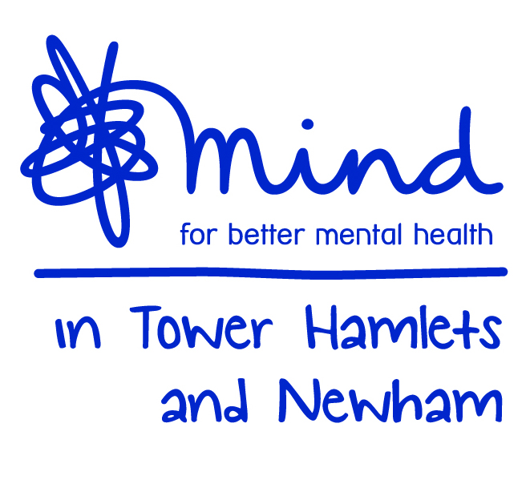
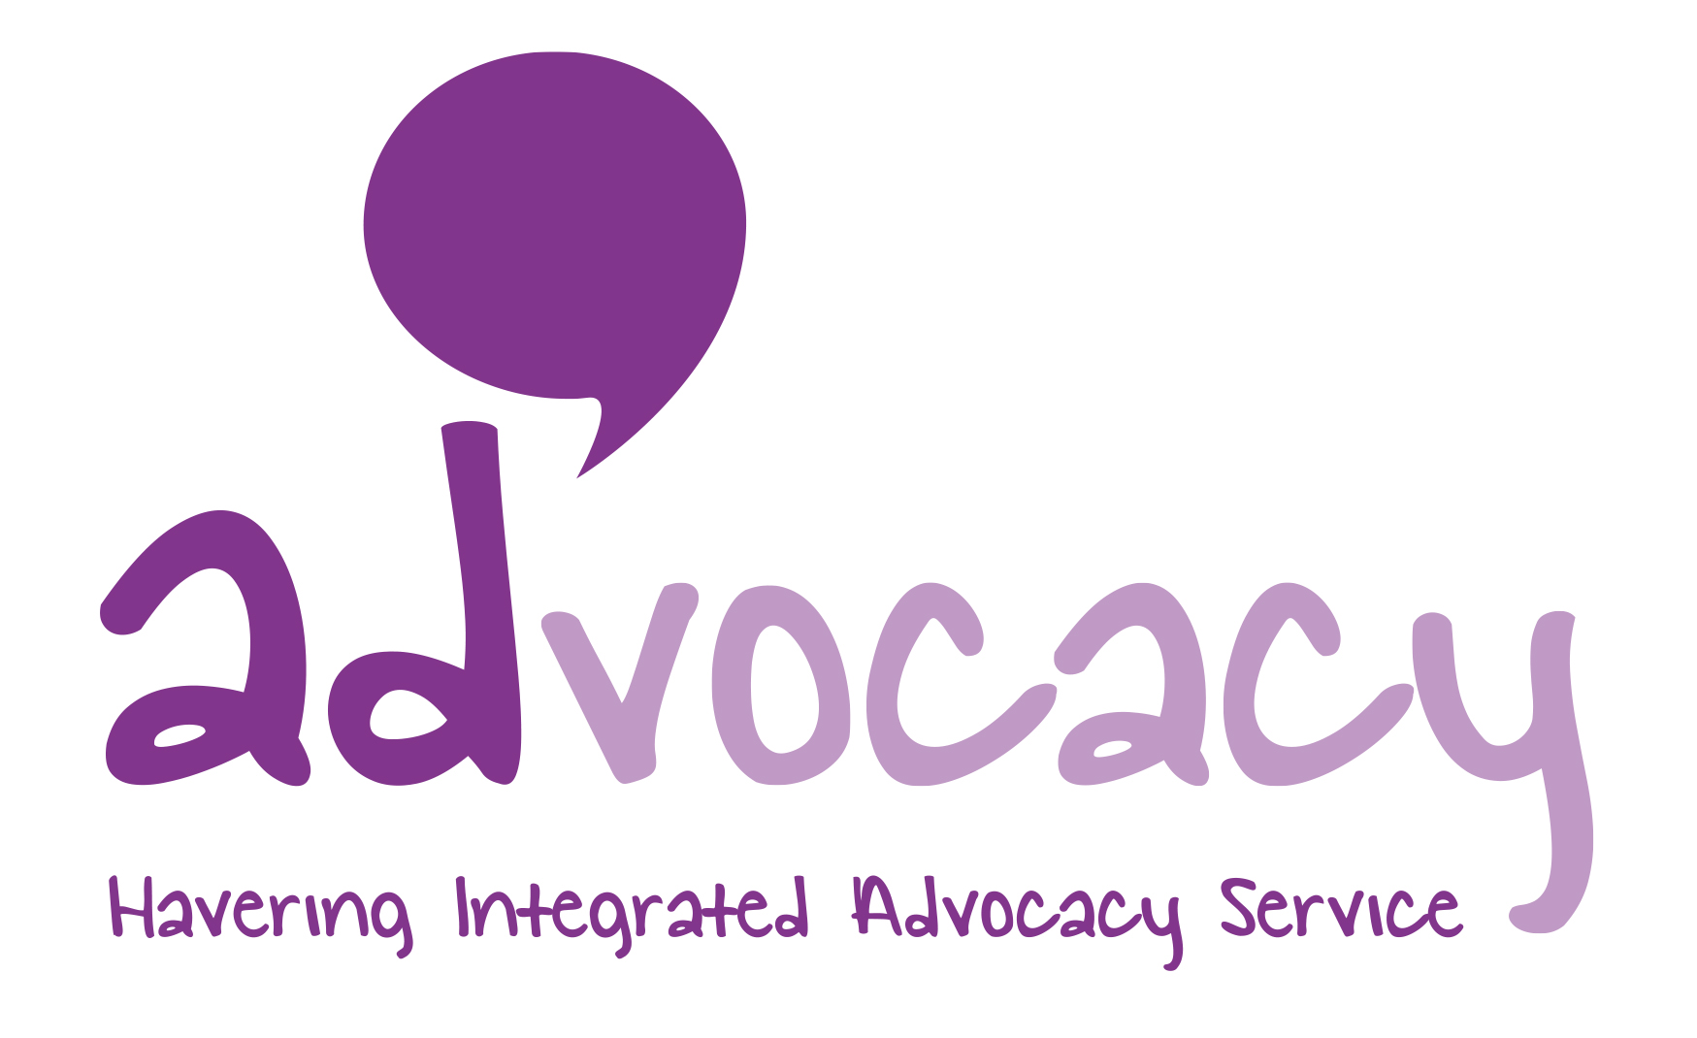


HAVERING INTEGRATED ADVOCACY SERVICE
REFERRAL FORM
IMCA/DOLS

Date of referral:

Client Name:

Current Place of Resident (at date of referral):
Postcode:

Telephone No:

Date of Birth:

What Is The Best Interest Decision? (please tick)
Serious Medical Treatment | Long Term Accommodation |  | Adult Protection/  Safeguarding |  | Care Review | RPR
Please describe the decision:

For Long Term Accommodation, what is the projected discharge date?

Date decision need to be made by: |  | Meeting Dates (please specify):
Details of Mental Capacity Assessment

Name of the professional who has deemed the referred person as lacking the mental capacity to make a decision about the referral issue:
What is their position?

Has a stage 2 functional assessment of capacity been carried out? | Yes |  | No
Does the referred person have a family member or friend who is considered appropriate to be involved? in the best interest decision? | Yes |  | No
If NO, what is the reason the family/friends are not involved?

Support, Risk and Communication
Please detail any support needs the advocate will need to provide:
Are there any current risks regarding the client that we need to be aware of? | Yes |  | No
If YES, please describe details of risk:

Does the client have any communication needs? | Yes |  | No
If YES, please provide details:
Professional Contact Details
Name of person making the best interest decision:
What is their role?

Organisation:

Contact details:
Telephone Number:

Email:
Please list any other relevant professionals who may be involved in the process:

Is the client aware of the referral being made? | Yes
Is the client aware of the referral being made? | No
Is the client aware of the referral being made? | N/A
Signature (referrer):
Signature (decision maker):

Please return the completed form to: | havering.advocacy@mithn.org.uk

Equal Opportunities Monitoring Details – please complete
Gender: | Male | Female | Transgender | Prefer not to say
Client Religion: |  |  | Prefer not to say
Client Sexuality: |  |  | Prefer not to say
Client Ethnicity: |  |  | Prefer not to say
Client Disability: | Yes; If yes, please state: |  | No
As a woman, are you pregnant, on maternity leave or returning from maternity leave? |  |  | Prefer not to say/NA

Havering Integrated Advocacy Service will confirm receipt of all IMCA referrals within 24 hours. If you have not received this confirmation, please contact the service on havering.advocacy@mithn.org.uk or call 01708 560 660 or 020 7510 1081.

